**Table of Contents**

Introduction …………………………………..1

Overview of Game Play…………………..1

Characters

FatBoy………………………….…………..2

Grandpa……………………………………2

Evil Gummy……………………….……..3

Enemies………………………………………….4

Controls………………………………………….5

Levels

ChocoLevel…………………..………....6

GumLevel………………………..……….6

Final Round……………………..……….6

How to Install………………………………….8

Computer Requirements…………………8

Credits…………………………………………….9

**Introduction**

You are Fatboy, a happy little boy whose Grandpa owns the world’s greatest candy factory. But one day while making a new experimental candy something went horribly wrong and now the candies are out to eat people. Led by the mysterious Evil Gummy they have taken over the candy factory and plan to conquer the entire world. It is up to you, Fatboy, and you’re never ending hunger for candy to stop Evil Gummy and save your grandpa’s candy Factory.

**Overview of Game Play**

FatBoy in a Candy Factor is an old school side schooling platformer with a splash of 3d to give it a more new school look. Your objective as Fatboy is to traverse the different levels of the candy factory, eating candy and gaining power-ups, without being eaten by evil candy. Defeat all three levels and save the candy factory.

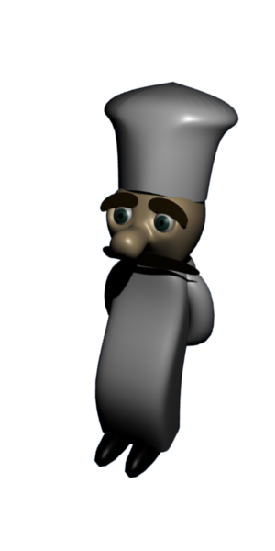

**Characters**

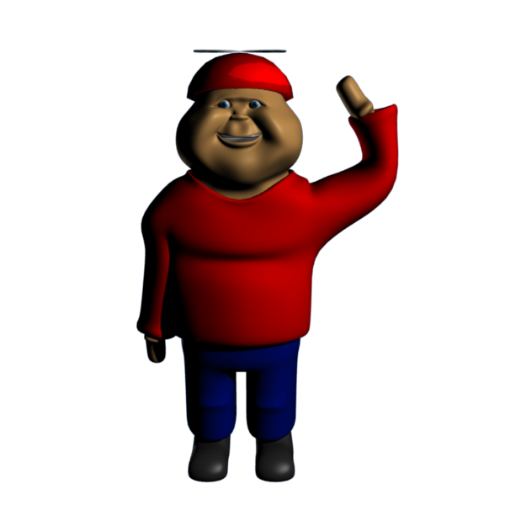**FatBoy**: The Hero of our story, Fatboy loves candy and he loves his Grandpa’s candy factory, which is why he is going to do everything in his power to save it, even if it means filling up on chocolate before supper.

**Grandpa:** Owner of the candy factory and creator of the new evil candy that is about to conquer the whole world. His only hope for rescue is his grandson’s incredible appetite for candy.

**Evil Gummy:** The mysterious candy mastermind who brought all the new evil candies together with a plot to take over the world.

**Enemies**

 Candy Corns: This one time enjoyable candy snack is out for revenge. Watch out as they try to take a bite out of Fatboy (Amazingly with no mouths!)

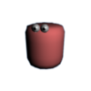

Gums: Though complacent compared to the other candies, these gums can greatly aid FatBoy in his quest (see Controls).

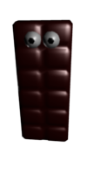Chocolate Bars: The most sinister of the bunch, this chocolate bars plan to make s’mores out of Fatboy and his grandpa.

**Credits**

**Jason Dobrinski – Lead Tech and Artist**

**Orlando Yanguas – Assitant Designer : ChocoLevel**

**Alex Kaigioglu ­– Tech Assistant : Final Round**

**Roel Bertens– Art Assistant: Gum Level**

**Thank You We Hope You Enjoyed**

**Fat Boy In A Candy Factory**

**How to Install**

This CD comes with all the content for the game as well as install versions of Blender for Windows, Mac OSX, and Linux. Windows users can run this game simply by executing the Play Game file from inside the cd. To run this game on another system, install the version of Blender require for your system. For more help with this you can. Once you have the newest version of Blender installed on you system, open the PlayGame.blend inside of blender. Once the file has loaded press ‘P’ to begin the game.

**Computer Requirements**

FatBoy in a Candy Factory requires a system with minimum system requires to run Blender to play. For ideal performance, system should meet the specifications set out on Blenders homepage. See [www.blender.org](http://www.blender.org) for more information on system requirements for running blender.

**Controls**

**Walk Mode:**

Right Arrow: Move Fatboy Right

Left Arrow: Move Fatboy Left

Up Arrow: Jump

Spacebar: Eat Candy

G: Blow Gum Bubble Mode (requires a Gumball)

H: Stick To Wall Mode (requires a Gumball)

**Bubble Mode:**

In bubble mode Fatboy can jump much higher, but be careful not to pop it.

**Stick To Wall Mode:**

Pressing H while next to a stickable wall will allow Fatboy to scale the wall.

Up Arrow/Down Arrow : Move Fatboy up and down the wall.

Left Arrow/Right Arrow: Jump off the wall